**Project Initialization and Planning Phase**

|  |  |
| --- | --- |
| Date | 10 July 2024 |
| Team ID | 739966 |
| Project Name | Beansense: Precision Bean Classification For Enhanced Agricultural And Culinary Applications |
| Maximum Marks | 3 Marks |

**Define Problem Statements (Customer Problem Statement Template):**

1. Farmers need a reliable system to accurately identify and classify bean varieties to optimize cultivation practices and enhance crop yields.
2. Food manufacturers require precise bean classification to maintain consistency in product quality and meet specific processing requirements.
3. Chefs and consumers seek a dependable method to select the ideal bean types for culinary applications, improving the quality and taste of their dishes.

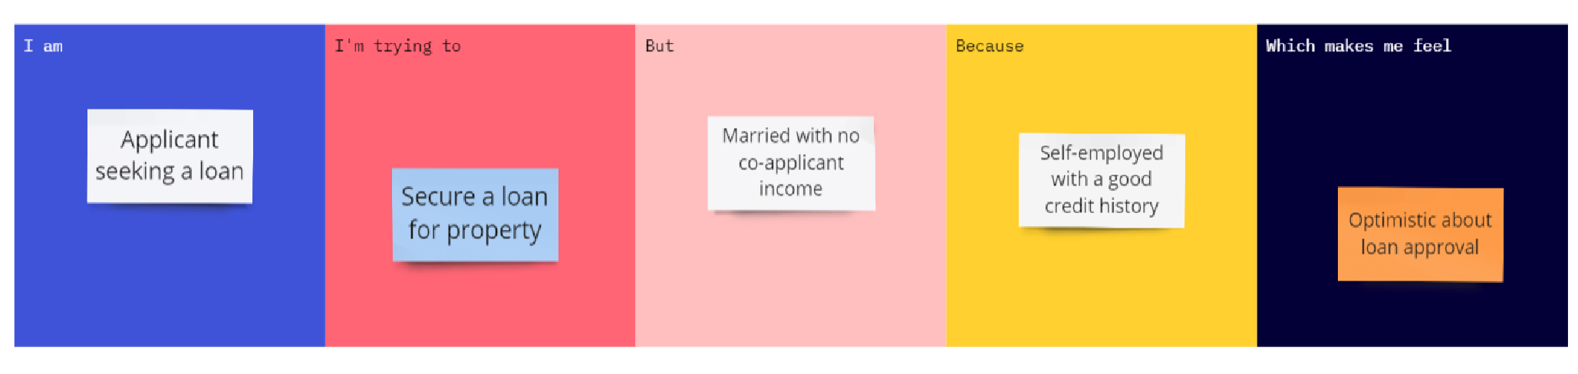

|  |  |  |  |  |  |
| --- | --- | --- | --- | --- | --- |
| **Problem**  **Statement**  **(PS)** | **I am**  **(Customer)** | **I’m trying to** | **But** | **Because** | **Which makes me feel** |
| PS-1 | A farmer. | Optimize my cultivation practices. | I struggle to accurately identify and classify different bean varieties. | There is no reliable system in place for precision bean classification.. | Frustrated and concerned about crop quality and yield. |